**DevNet Workshop: Extreme automation: Meraki APIs and the Alexa virtual assistant.**

**Session ID**

**DEVNET-2129**

**Speakers:**

**Juan Antonio Castilleja**

**Uriel Arriaga Alvarado**

# Learning Objectives

Upon completion of this lab, you will be able to:

* Understand the flow of Alexa request
* How to create python code into Lambda
* Create new skills to call personalized code

# Scenario

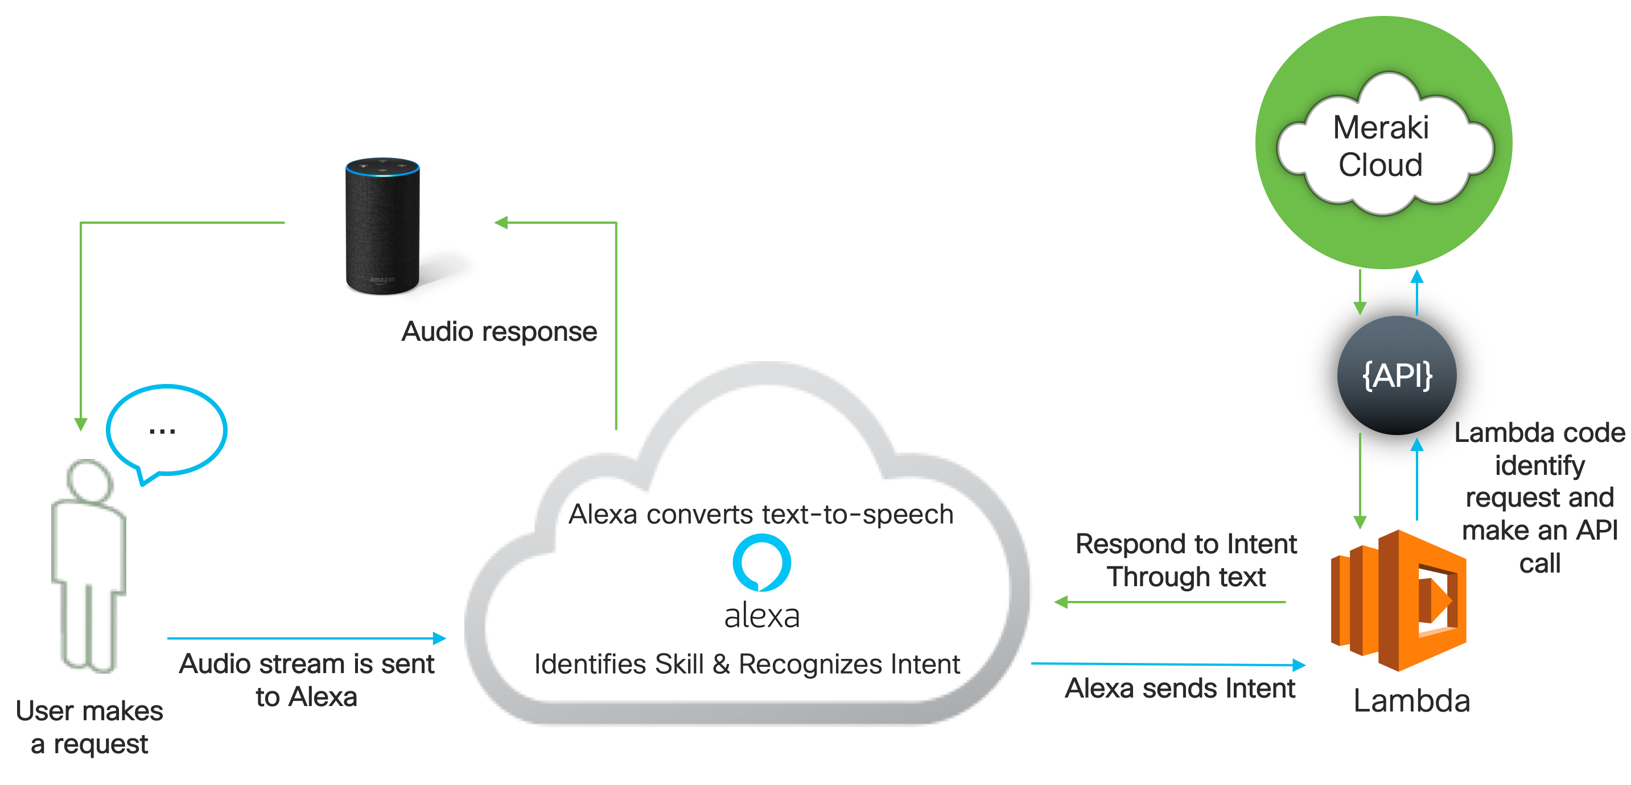

Figure 1. Lab scenario

.

# Prerequisites

Have an Account on:

1. Meraki APIs Knowledge
2. Basic Programing skills

# Task 1: Create an Alexa Skill

1. Go to [developer.amazon.com](http://developer.amazon.com/)
2. Click in “Developer Console”
3. Login as Prompted. Credentials will be given to you by the instructor.
4. Click on Alexa, then Click on Alexa Skill Kit

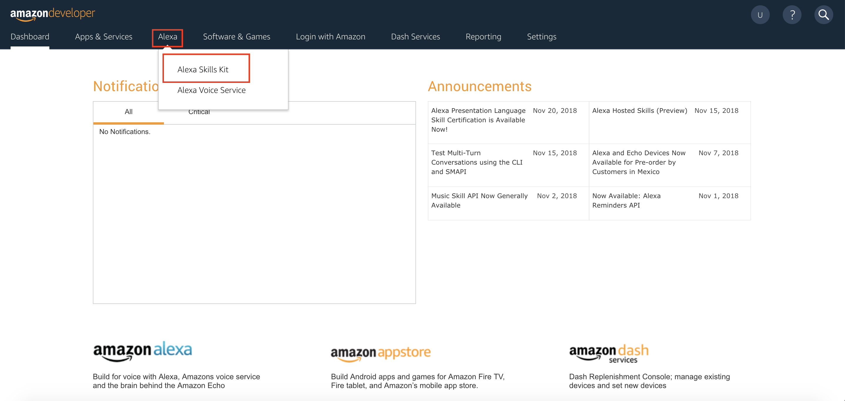

1. Click the create skill button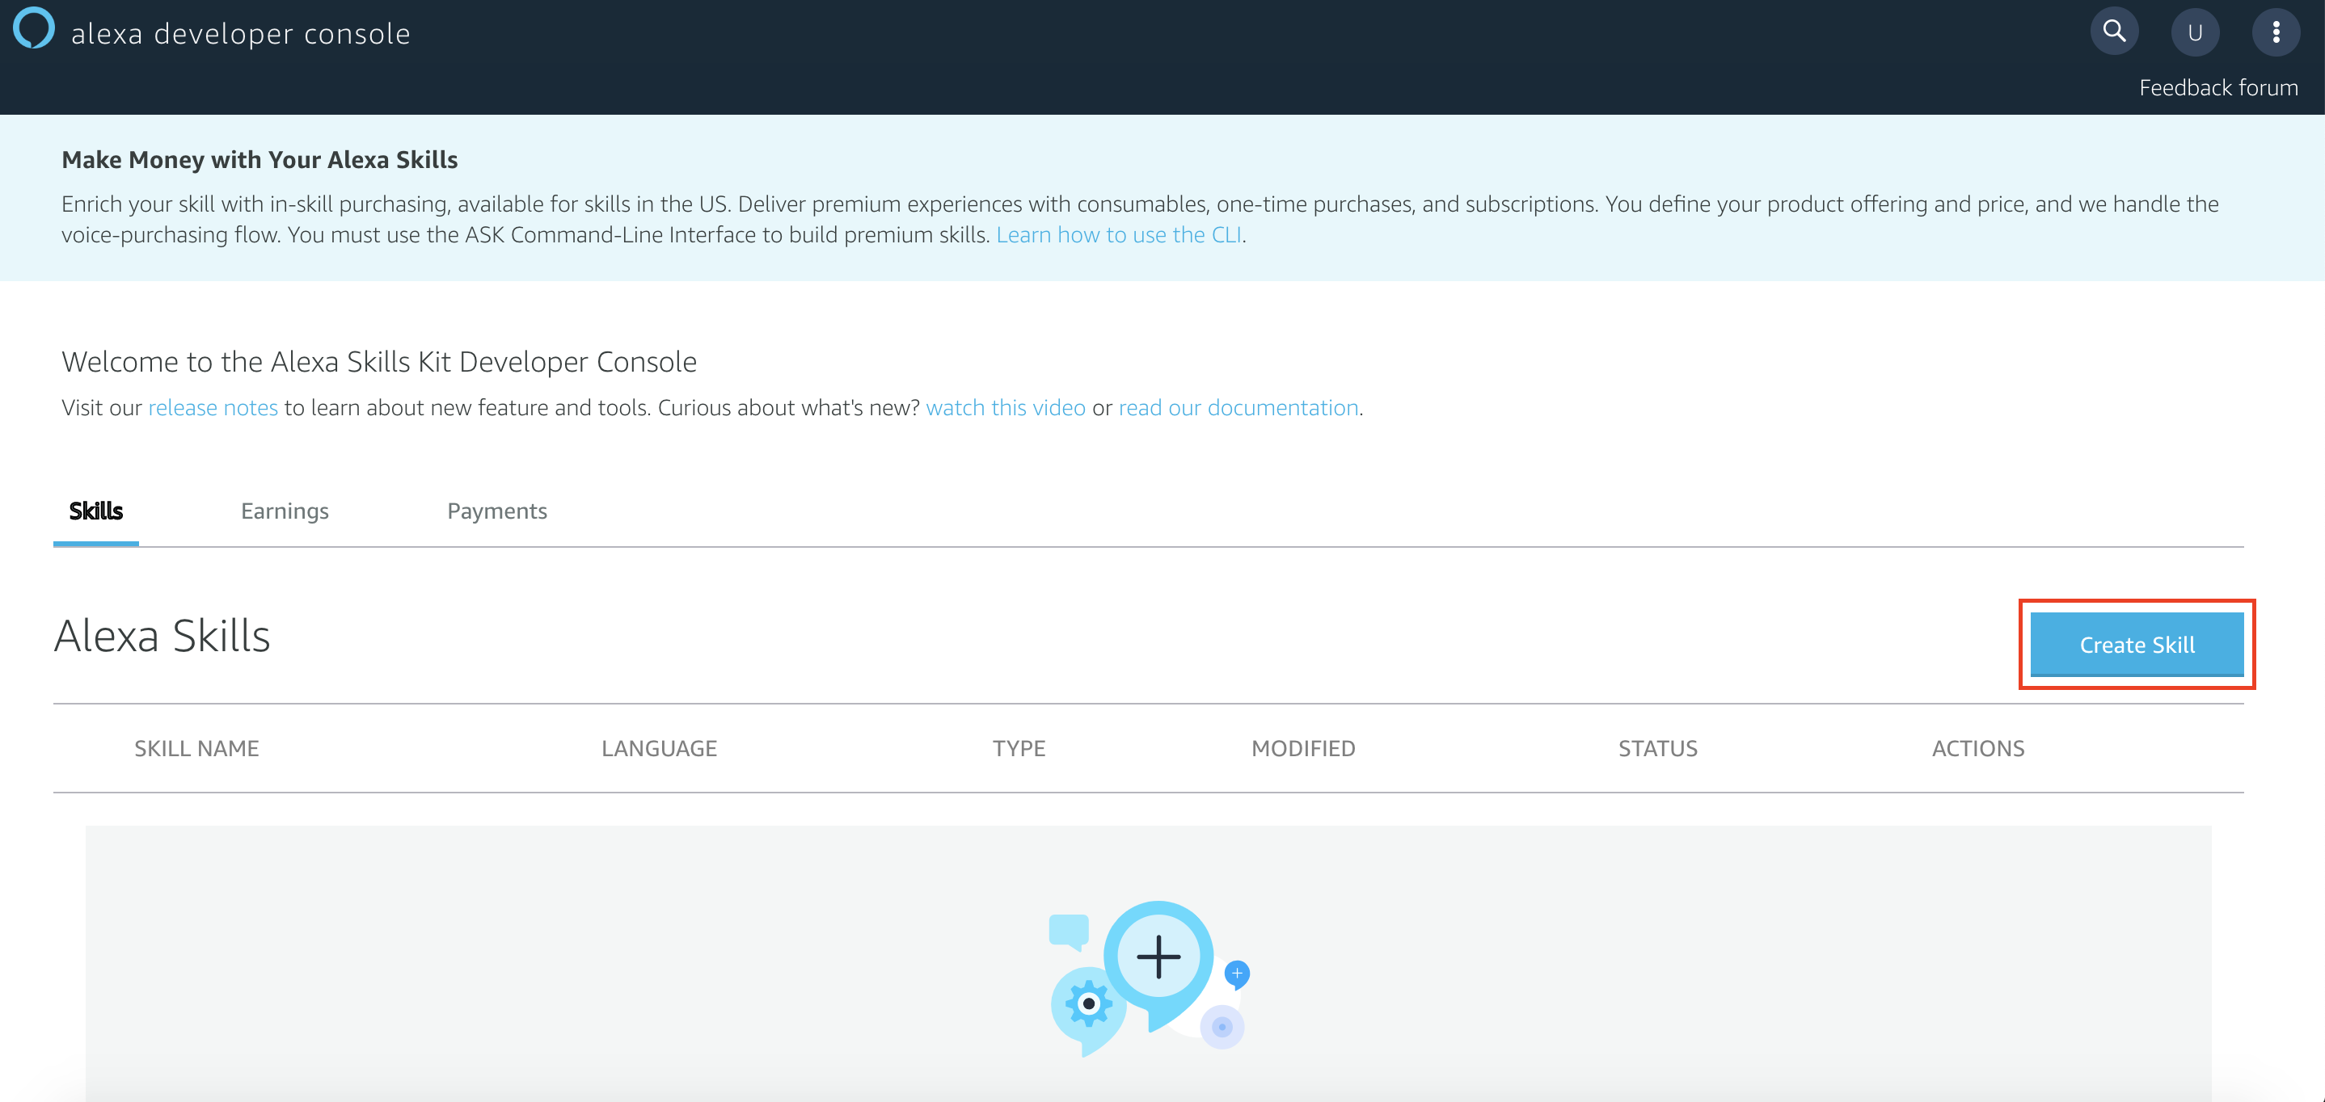
2. Fill the “Skill Name” with “Meraki”, put the “Default language” to “English (US)” and select the “Custom” Option As a model for the skill. Then Click “Create skill”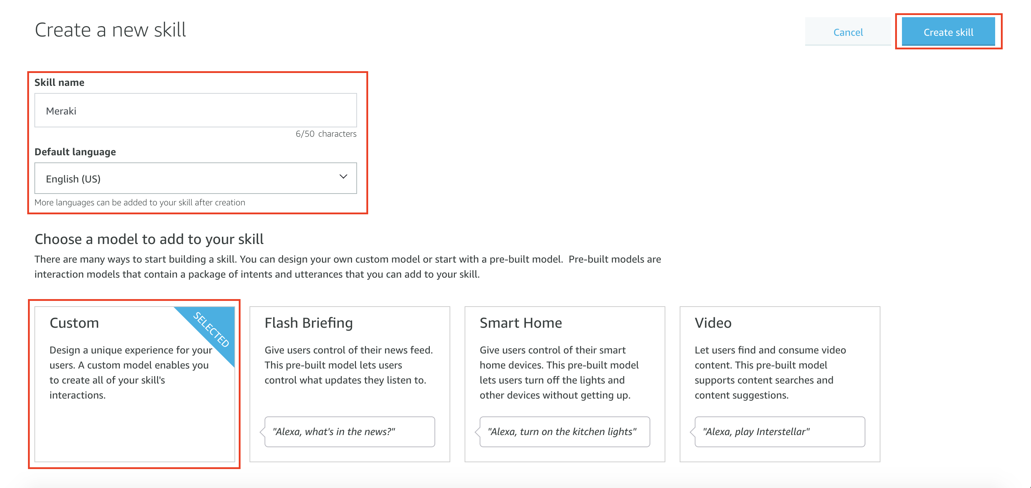
3. Choose “Start from Scratch” as a template, an click “choose”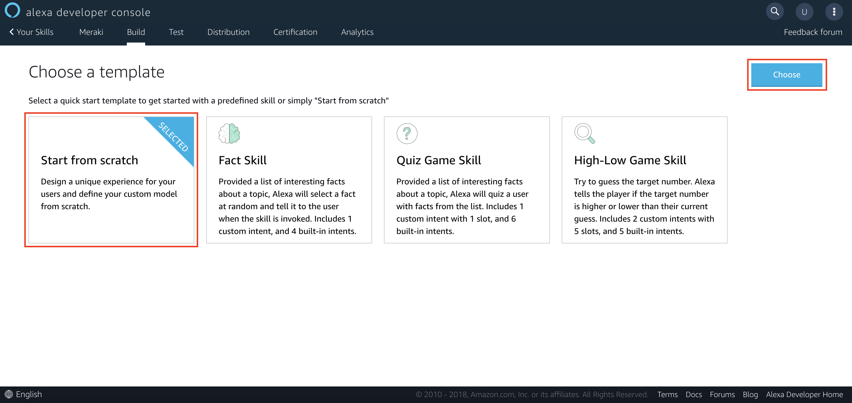
4. Click “JSON Editor”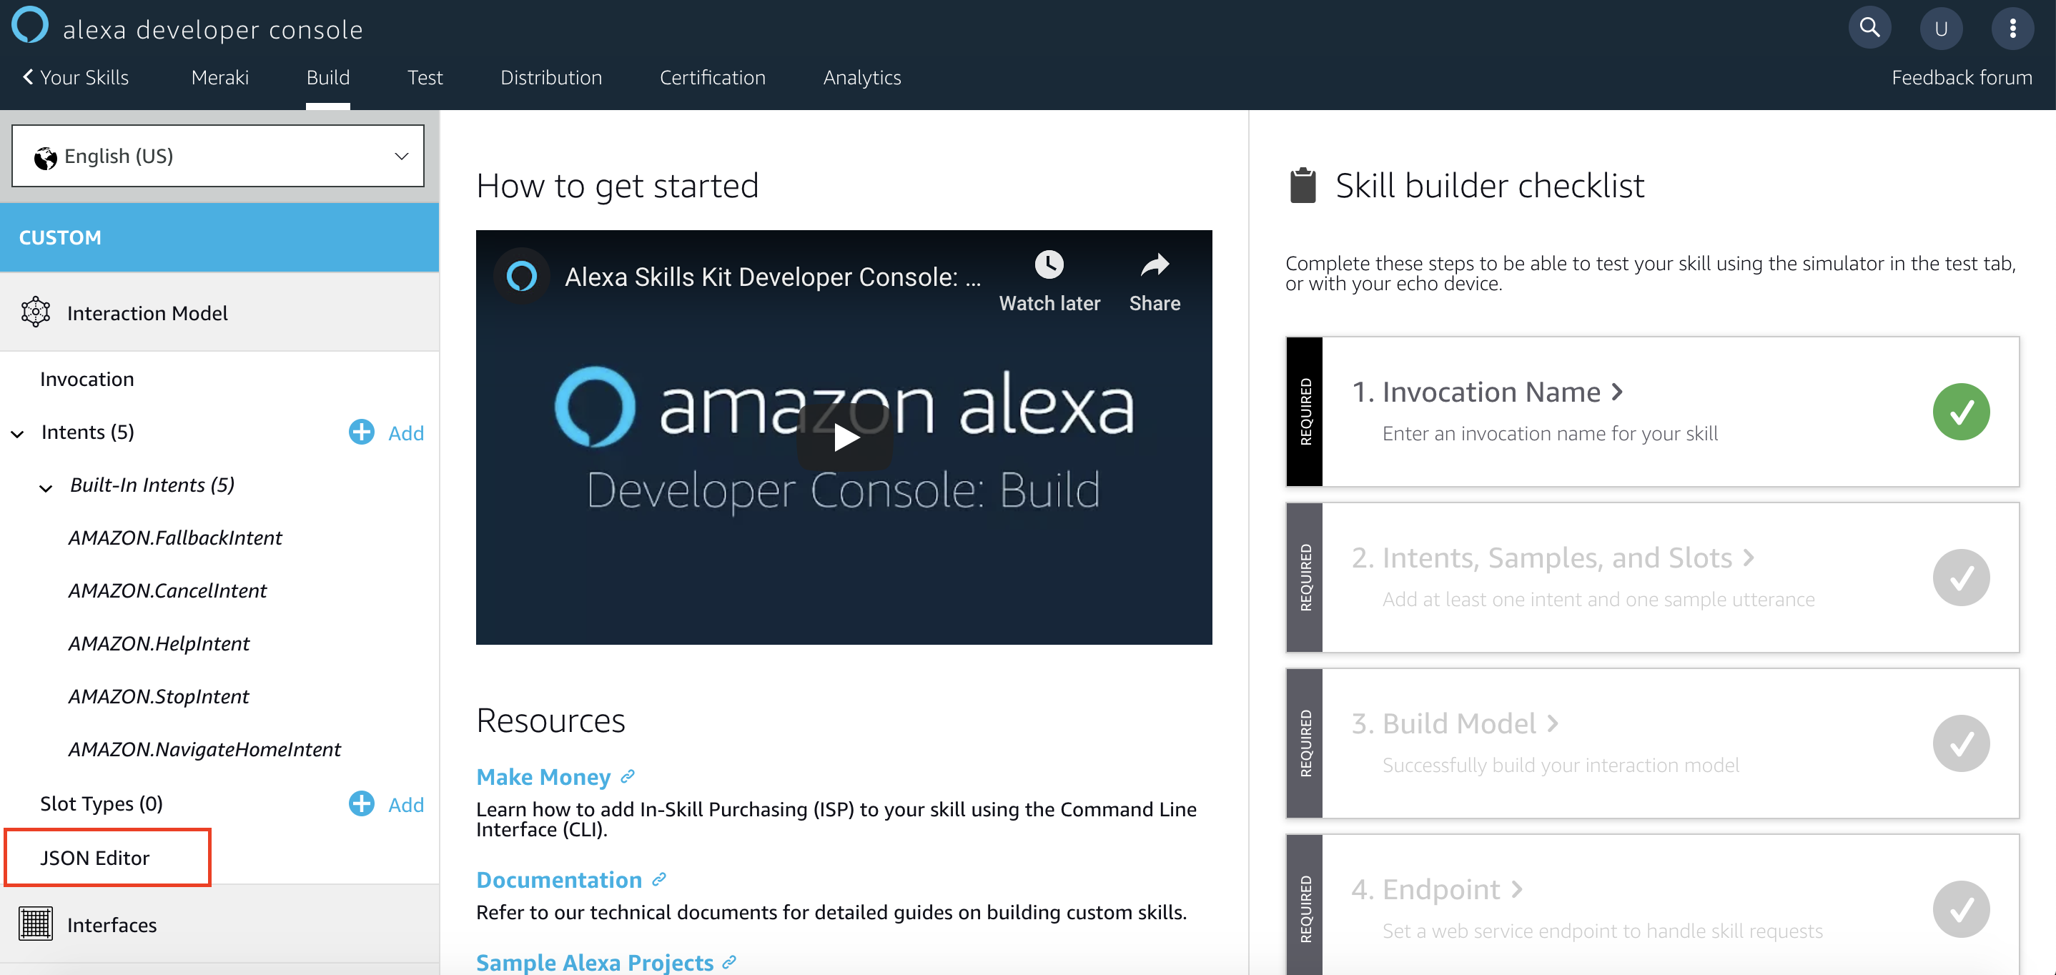
5. Copy and Paste the JSON Available in intentJSON.txt within <https://github.com/Momoyactly/Extreme-automation> and click “Save Model” 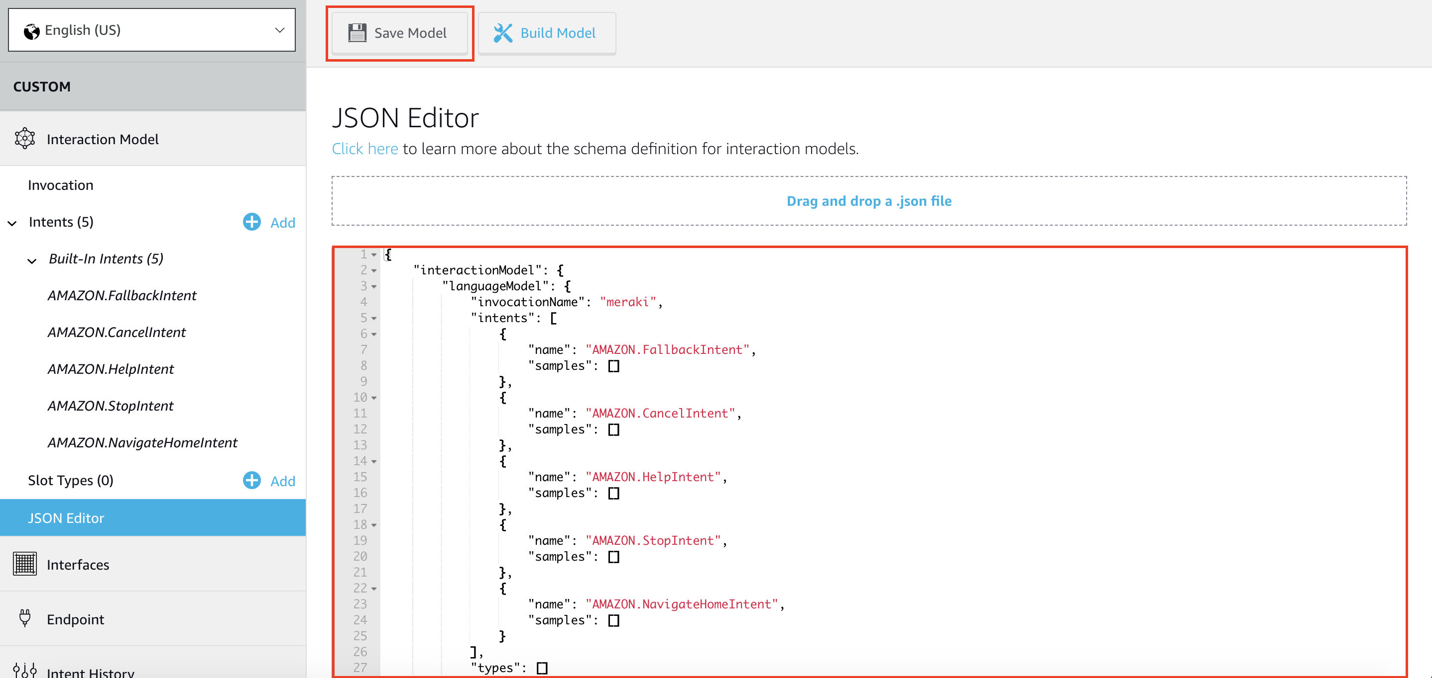
6. if everything ins Ok you should see a green message in the inferior right corner, and in the left side the “Intent tree” Should look like in the image below.(Checkpoint)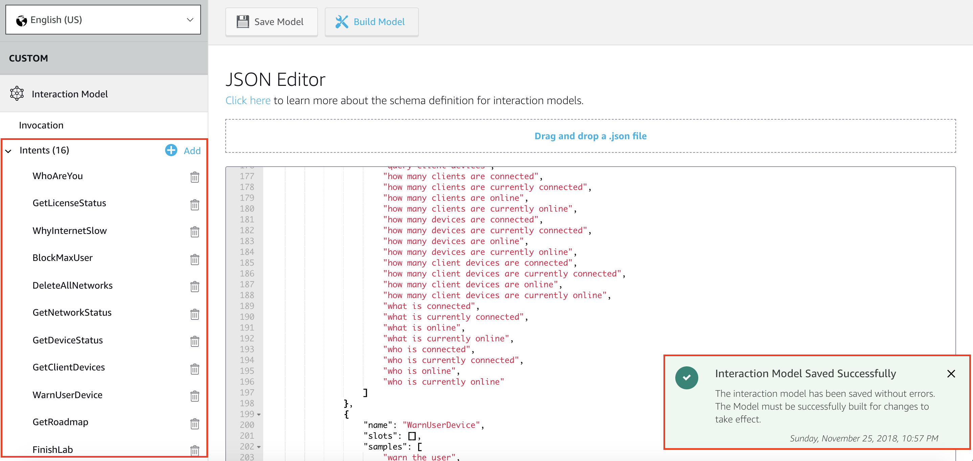
7. Click Endpoint in the right Panel, then click “AWS Lambda ARN” In the “Default Region” field we will copy the ARN given to us by Lambda in the next task, so we will come back to this Screen.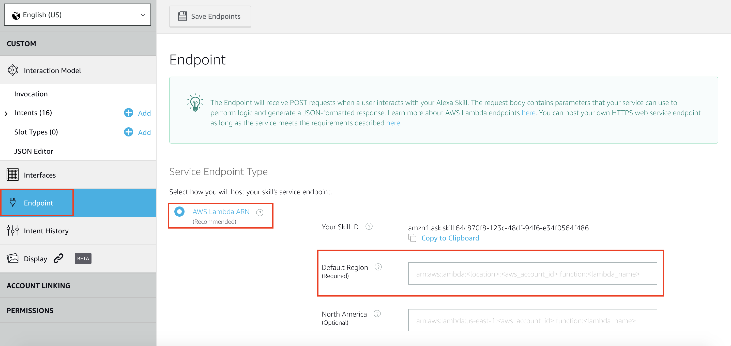

# Task 2: Create the Lambda function

Nam nec lacus luctus, vestibulum ex non, convallis elit. Pellentesque habitant morbi tristique senectus et netus et malesuada fames ac turpis egestas. Mauris ultrices lorem mauris

1. Login to <https://207212920803.signin.aws.amazon.com/console>

User: podx (x been the number assigned by the Instructor)

1. Click Services in the upper bar, then type lambda, and click the lambda option that appears.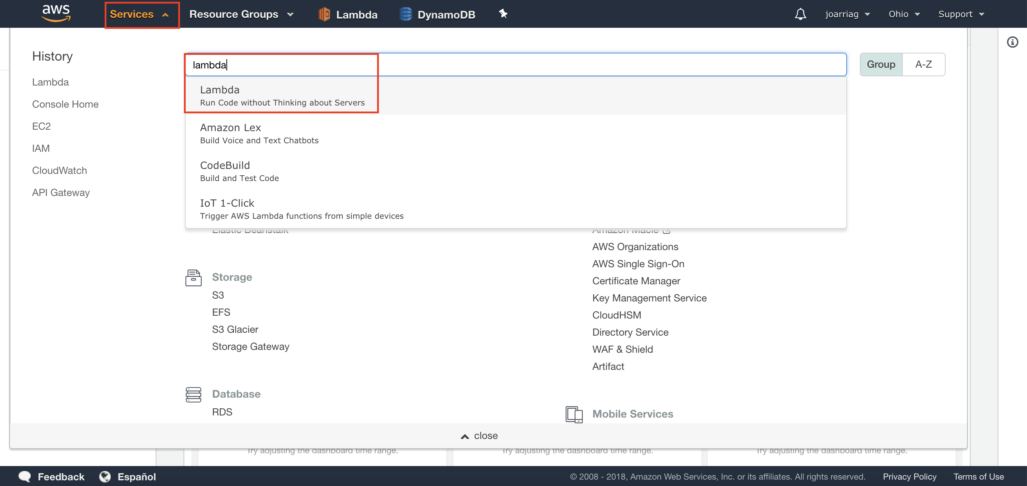
2. Make sure that you are in US East. Then click “Create a function” 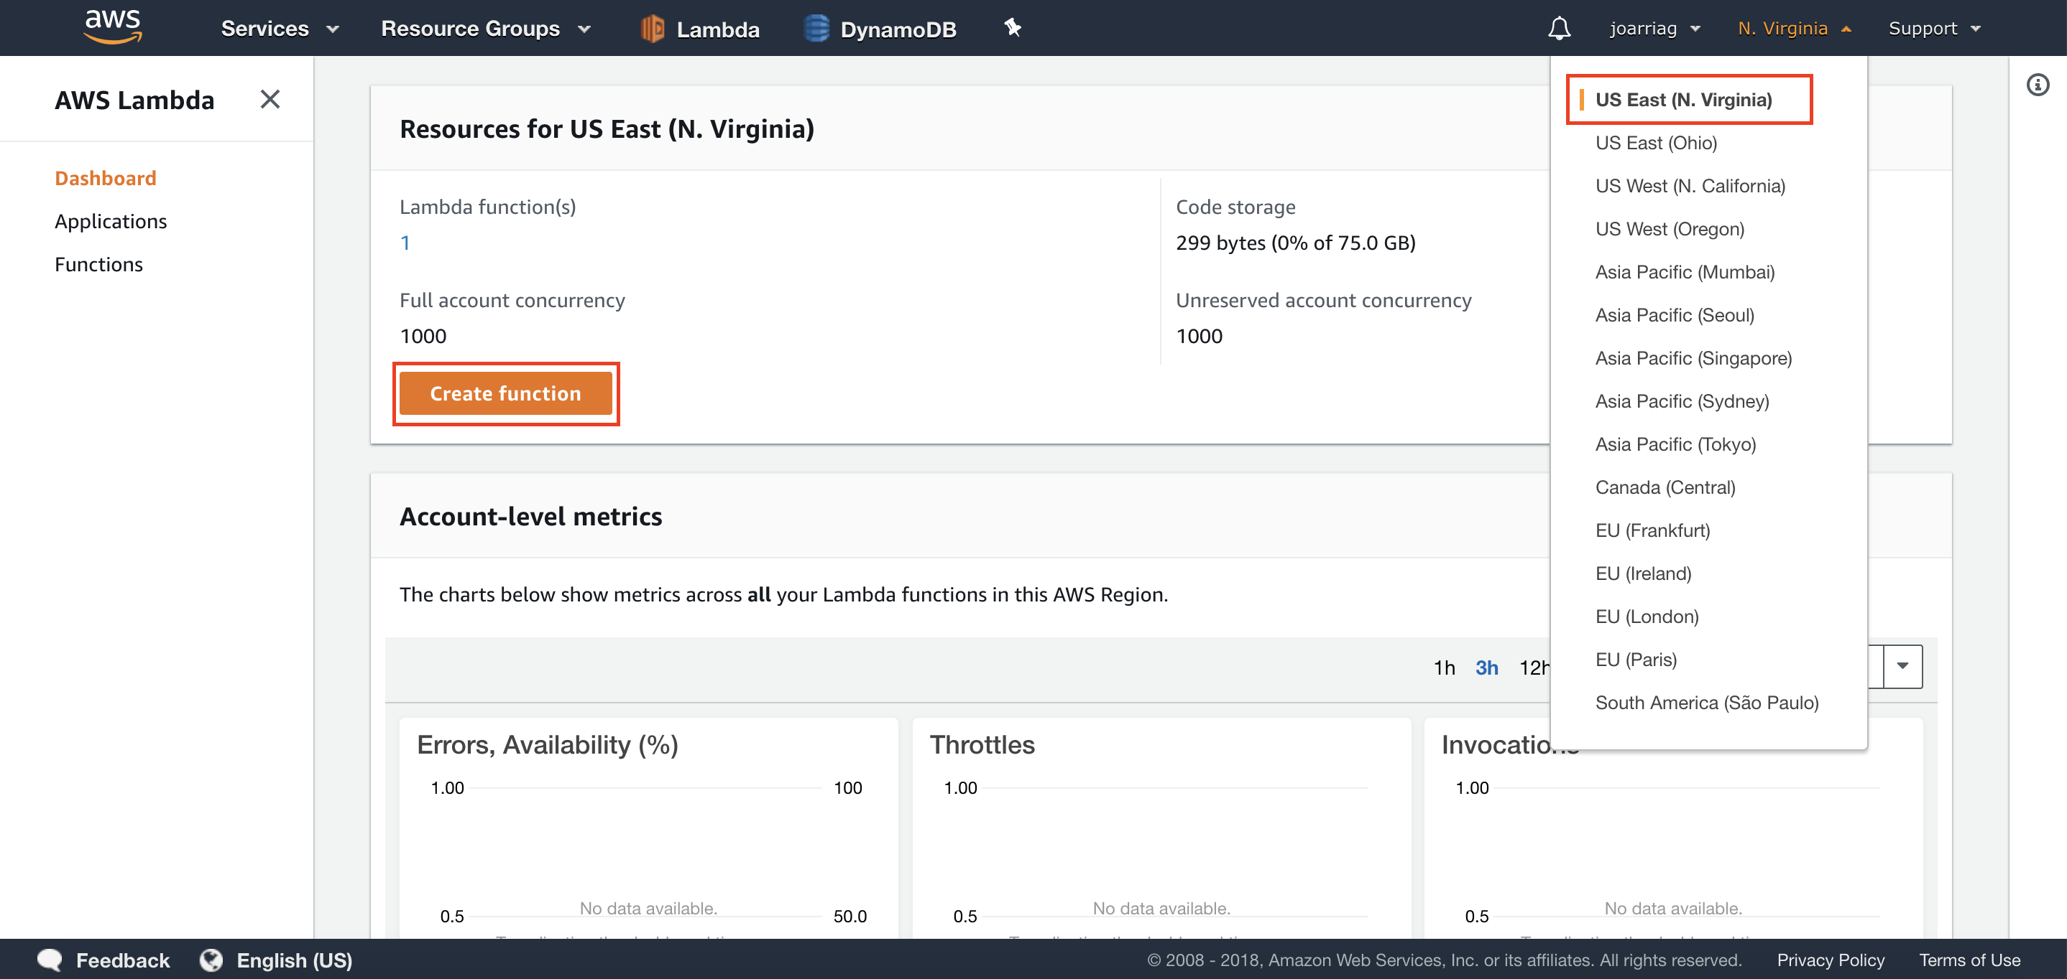

Choose “Autor from scratch”, write Merakix (x been the number assigned by the Instructor)

1. in the “Name” field, select “Python 3.6” in “Runtime”. Then click “Create a custom role” in the “Role” menu. You will be taken to another window and the you will come back.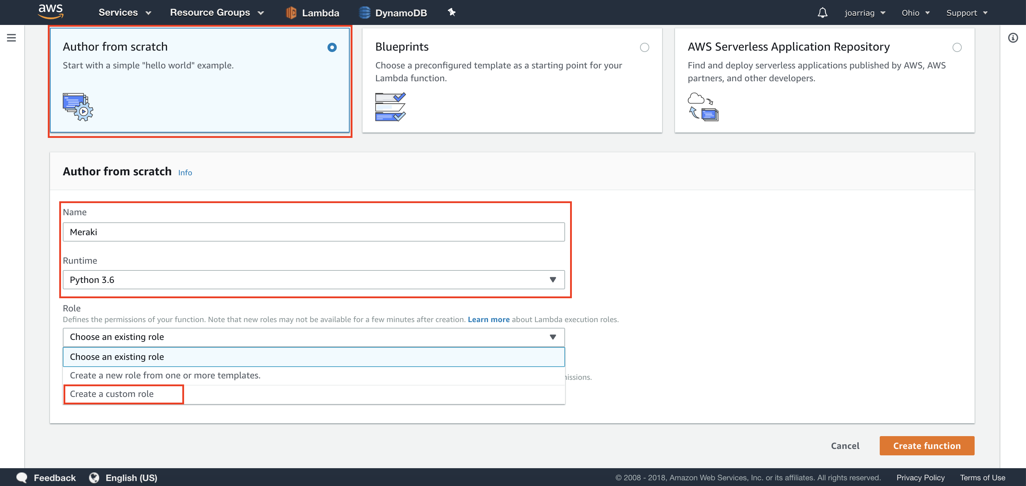
2. Select a “Create a new IAM Role”, and write “lambda_basic_execution” in the “Role name”. Then click “Allow”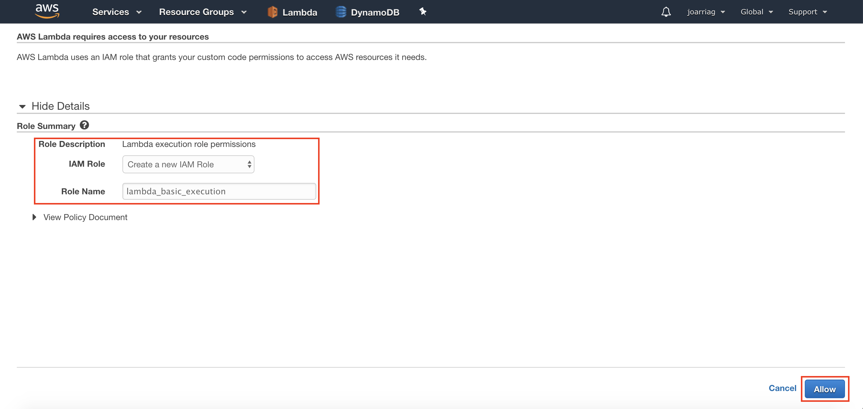
3. Choose “Choose an existing role” in the “Role” menu, and choose “lambda_basic_execution” ,that we just created, from the “Existing role” menu. Then click “Create function”.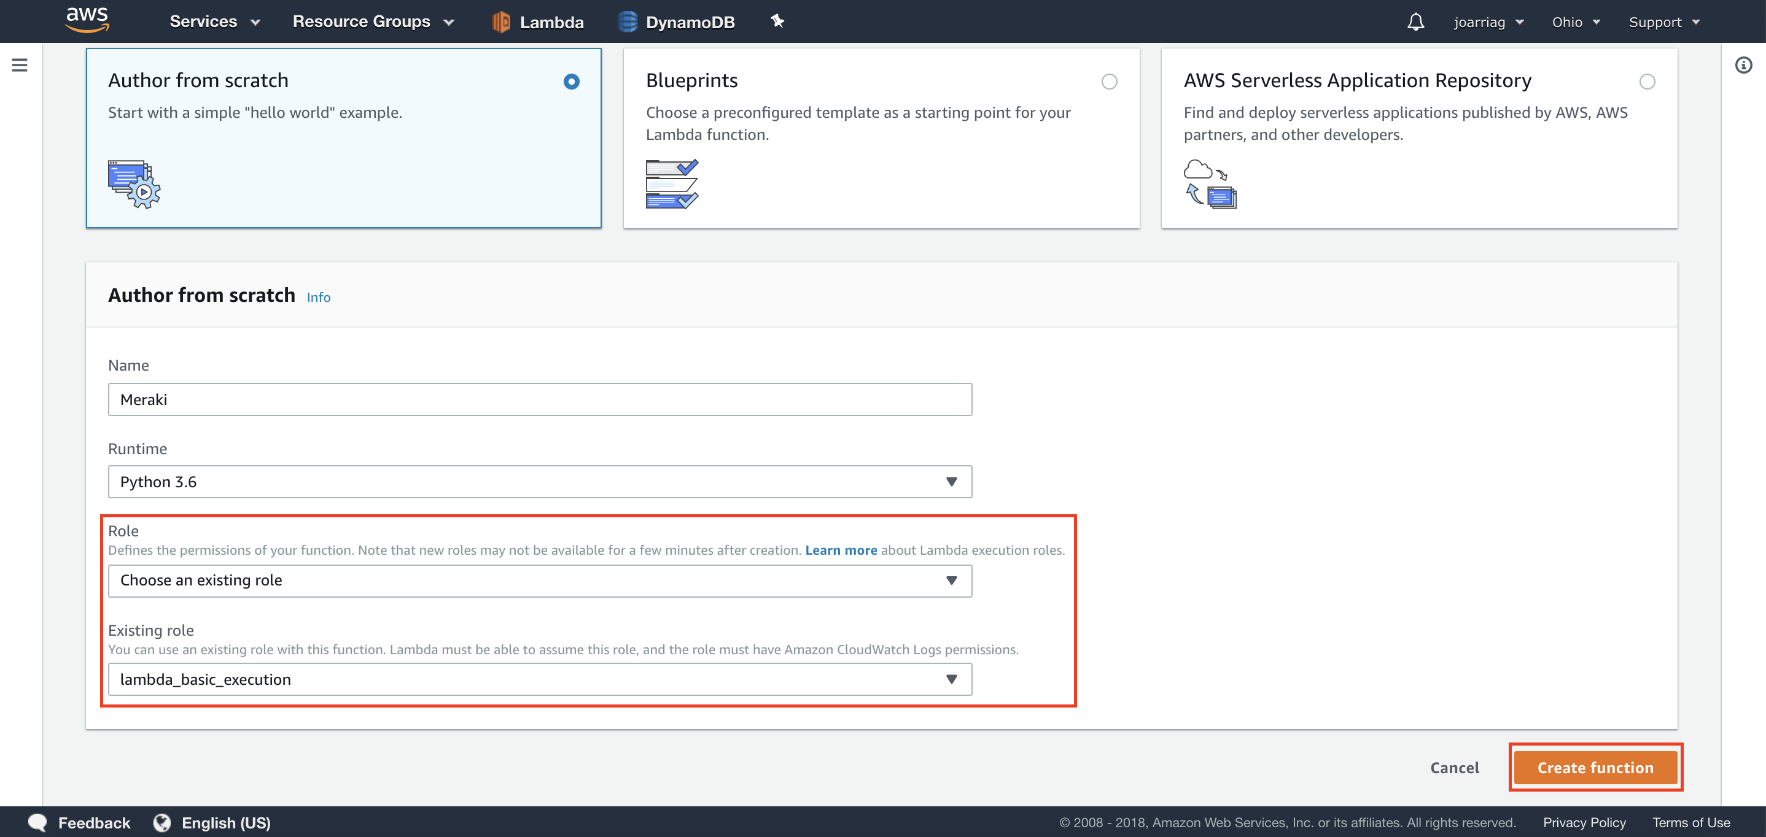
4. Click in “Alexa Skill Kit”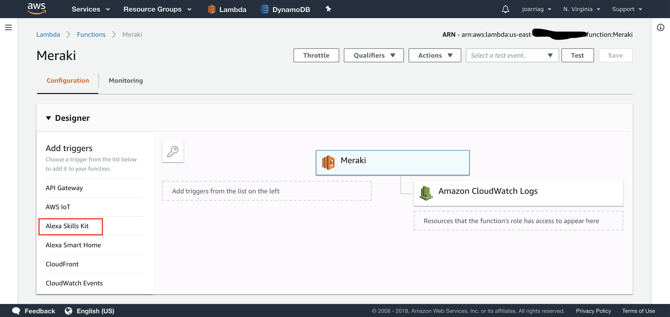
5. Click were it says “Configuration required” and the field “Skill ID” copy the value we get in the previous task. The click “ADD”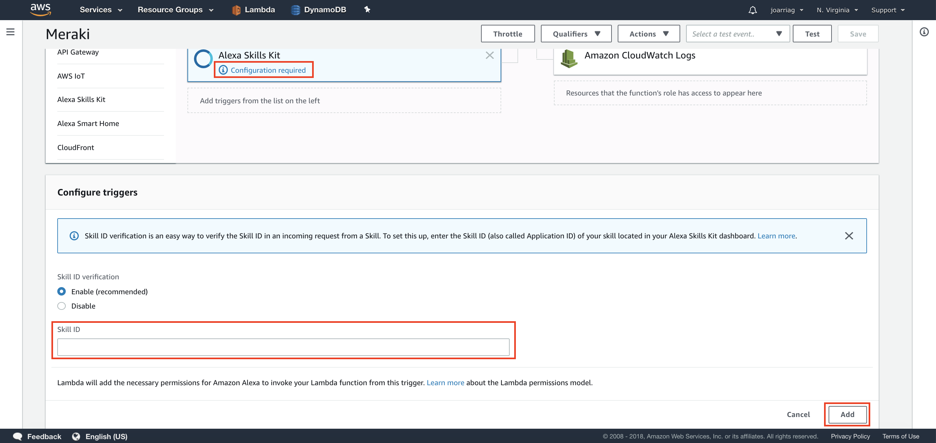
6. In the same page in the upper part, click “SAVE” the copy the ARN value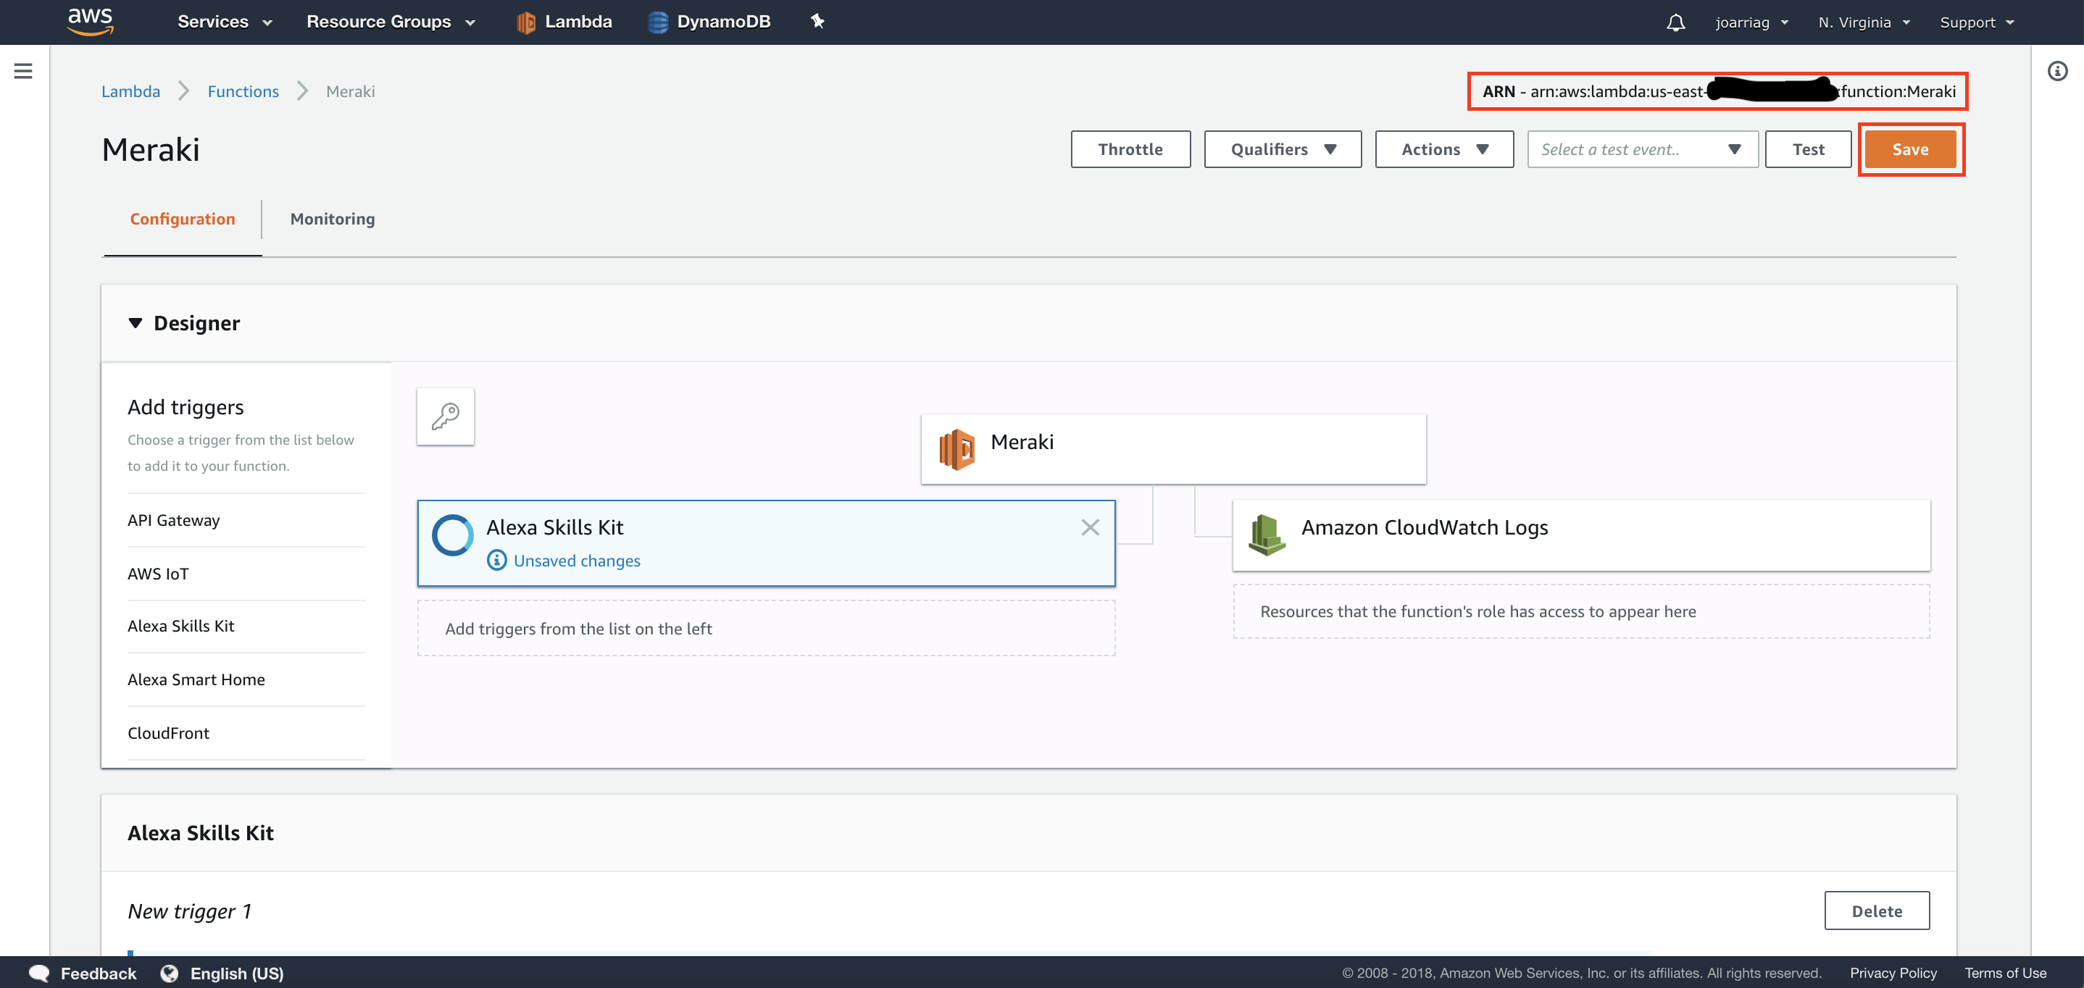
7. Click in the lambda button of “Meraki”, choose “Upload a .Zip file” an click Upload to add the code available in: <https://github.com/Momoyactly/Extreme-automation> Then click “Save”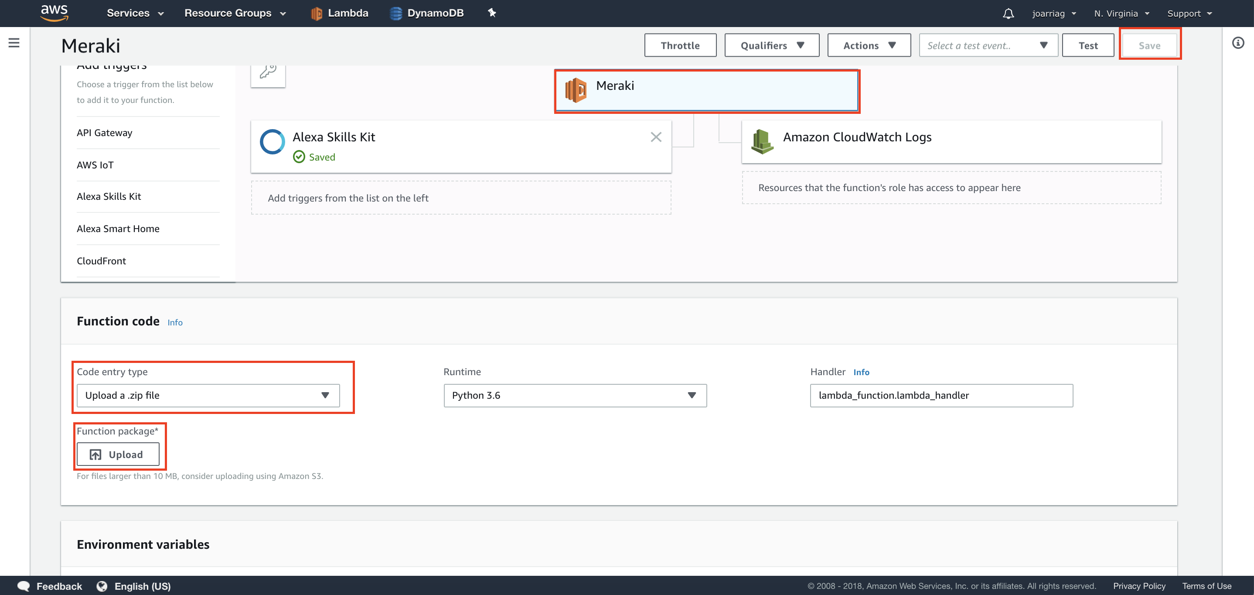

# Task 2: Integrate Alexa with Lambda

Nam nec lacus luctus, vestibulum ex non, convallis elit. Pellentesque habitant morbi tristique senectus et netus et malesuada fames ac turpis egestas. Mauris ultrices lorem mauris

1. Return to [developer.amazon.com](http://developer.amazon.com/) in the menu “Endpoints” and paste the ARN value in the “Default Region” field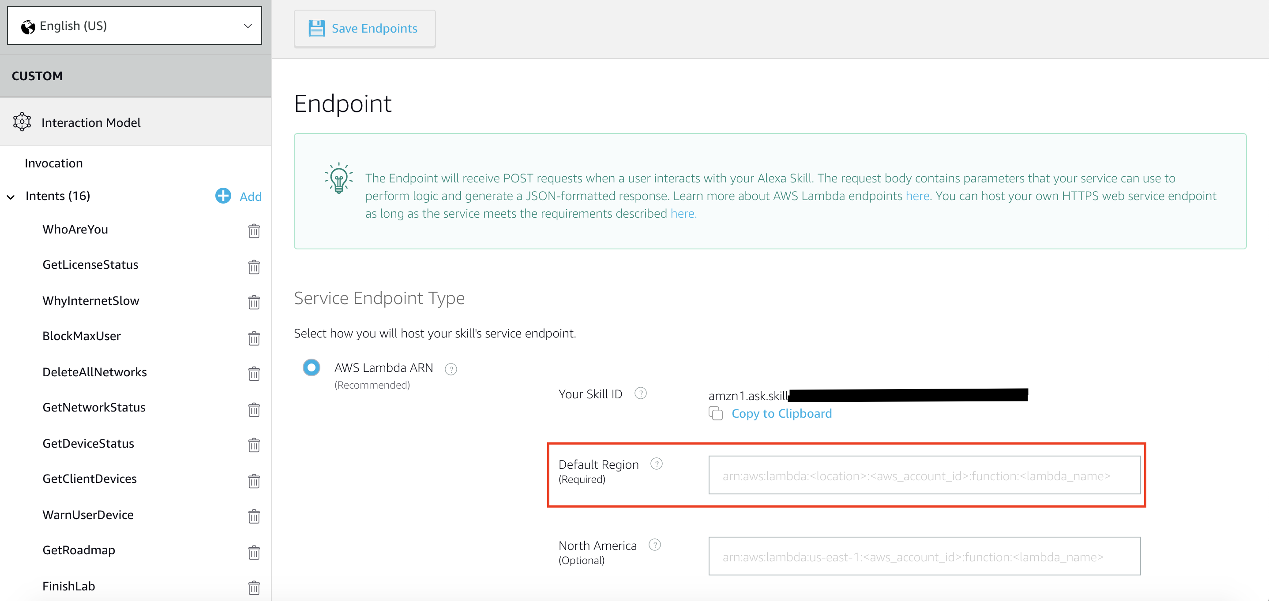

# Task 3: Test with Alexa!

Nam nec lacus luctus, vestibulum ex non, convallis elit. Pellentesque habitant morbi tristique senectus et netus et malesuada fames ac turpis egestas. Mauris ultrices lorem mauris

1. Go to “Test”, “Enable test for this skill” and say or write “ask Meraki to get network status”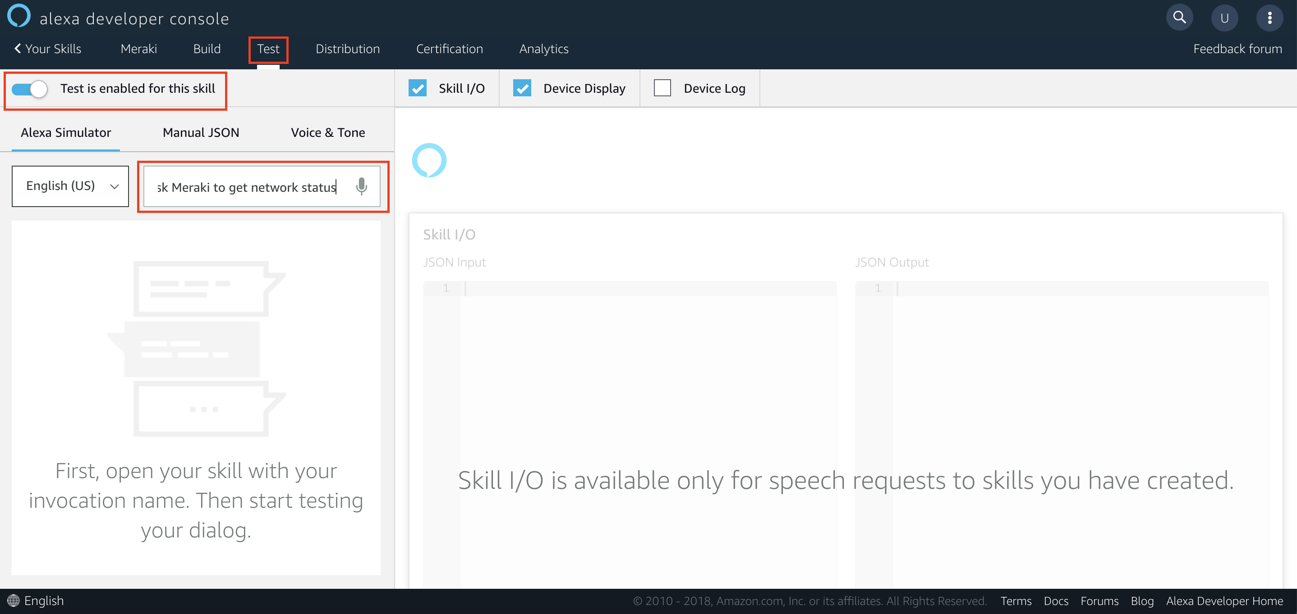

# Challenge: Add a new skill to create a new network

All the documents mentioned are available in: <https://github.com/Momoyactly/Extreme-automation>

An updated version with the new skill is available in the folder newSkillVersion.

1. Modify the Json in the “Alexa Developer Console” with the code in jsonNewSkill.txt. Then build an save the skill
2. Add the method available the updateLambdaFuction.txt in the lambda_Fuction.py in lambda. Then Save the function.
3. Modify the on_intent method in the lambda_Fuction.py in lambda. An example is available in updateLambdaFuction.txt. Then Save the function.
4. Try the new Skill.